**UIA Documentation**

The UIA is running on a Raspberry Pi 3 B+.

The resistor values for the resistors used is**: 1.2k Ohms 5%**

Link to the toggle switches being used: <https://www.amazon.com/Baomain-Toggle-position-mounting-terminal/dp/B01N2RLMCU/ref=sr_1_18?keywords=baomain+of+off+switch&qid=1556144073&s=industrial&sr=1-18>

A diagram of the GPIO pins is provided on the next page.

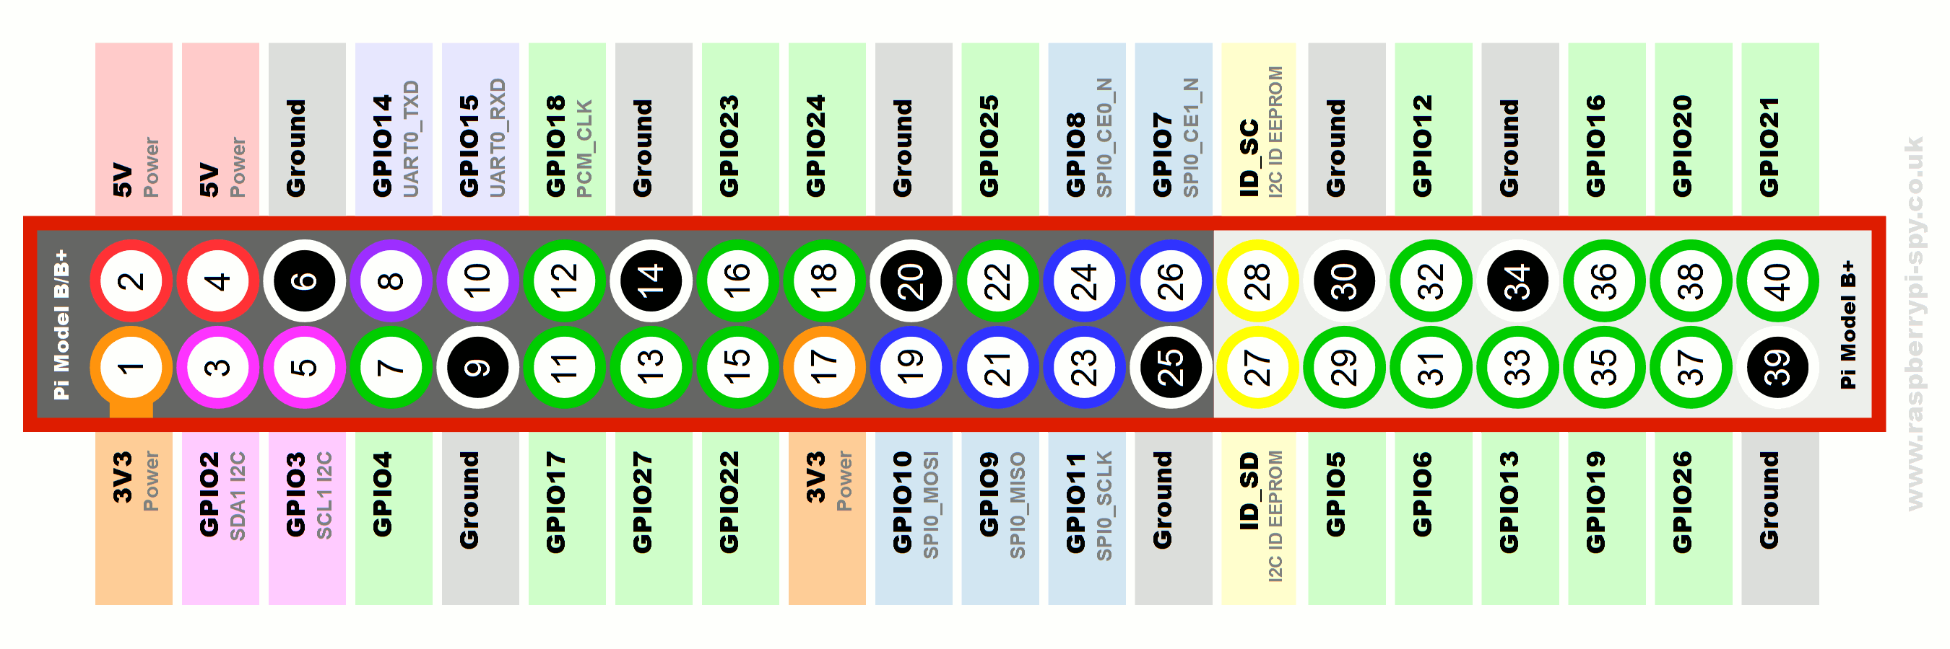

**GPIO 16** Controls **EV2 WASTE** Switch

**GPIO 17** Controls Yellow Light for **DEPRESS PUMP**

**GPIO 4** Controls Green Light for **DEPRESS PUMP**

**GPIO 21** Controls **O2 VENT** Switch

**GPIO 20** Controls **EV2 OXYGEN** Switch

**GPIO 26** Controls **EV2 SUPPLY** Switch

**GPIO 27** Controls Light for **EMU1 POWER**

**GPIO 9** Controls **EV1 WASTE** Switch

**GPIO 10** Controls **EV1 SUPPLY** Switch

**GPIO 22** Controls **EMU1 POWER** Switch

**GPIO 25** Controls **EV1 OXYGEN** Switch

**GPIO 18** controls **DEPRESS PUMP** Switch

**GPIO 23** Controls light for EMU2 POWER

**GPIO 24** Controls **EMU2 POWER** Switch